Standard Operating Procedure for:
COVID 19 Swabbing prior to endoscopy at St Mark’s

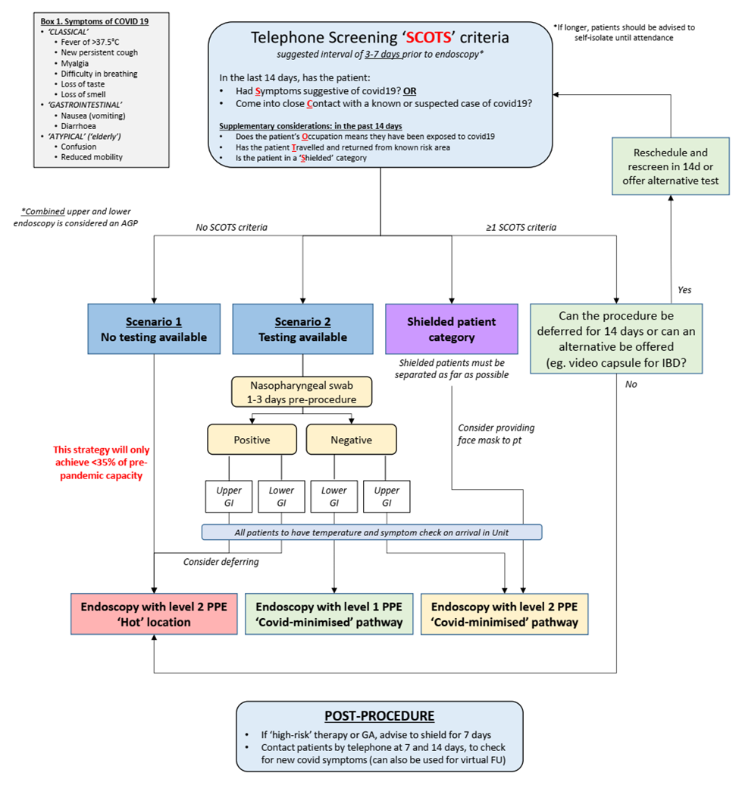
British Society of Gastroenterology guidance on recommencing gastrointestinal endoscopy in the deceleration and early recovery phases of COVID-19 pandemic - https://www.bsg.org.uk/covid-19-guidance-advice-documents/

Swabbing timetable and COVID – 19 PRE- QUESTIONNAIRE

Endoscopy day | Monday | Tuesday | Wednesday | Thursday | Friday | Saturday | Sunday
Swab AM | Thursday endoscopy | Friday endoscopy |  |  | Monday endoscopy | Tuesday/ Wednesday endoscopy
Swab PM
Result | Tuesday/ Wednesday result 48 hrs* | Thursday result 24hrs | Friday result 24hrs |  |  | Monday result 24hrs | Tuesday/ Wednesday result 24 hrs

*Staff available to check results

- Patients will be called prior to their screening colonoscopy as above
- The patient will be asked to wear a mask and have their temperature taken on arrival to STM OPD (Out- patient dept.)
- The COVID-19 pre questionnaire will be completed
- The patient will be swabbed
- The patient will receive their appointment letter, bowel preparation and informed consent process will take place if this has not been done
- The patient will be contacted to inform them of their swab result prior to taking bowel preparation.

Appendix 1:
PATIENT STICKER

COVID – 19 PRE- QUESTIONNAIRE

1. Have you had the following symptoms in the last 14 days (tick box)?
Fever >37.5 C Loss of taste Confusion (in elderly)
New persistent cough Loss of smell Reduced mobility (in elderly)
Myalgia Nausea (vomiting)
Difficulty in breathing Diarrhoea

If yes, escalate______________________________________________________________

2. Have you come into contact with a known or suspected case or COVID-19 in the last 14 days?

If yes escalate

3. Could you possibly have been exposed to COVID-19 because of work (Occupation) in the last 14 days?
If yes escalate

4. Have you travelled and returned from known COVID-19 risk areas in the last 14days?
If yes escalate

5. Have you received a letter advising you to shield?

If yes escalate

PRECAUTIONARY MEASURES (Remind patients re: below)

- Temperature check on arrival to endoscopy
- Face mask provided and worn on arrival to endoscopy
- No visitor policy
- Waiting times
- Transport method (bring appointment letter as proof re: lockdown)

